VOICE BASED EMAIL SYSTEM FOR BLIND AND HANDICAPPED PEOPLE
Prof.Savita Adhav^{1,}Khizar Bagban², Aniket Bali³, Akash Shendge⁴
^{1,2,3.4} G.H.Raisoni College of Engineering and Management Chas, Ahmednagar 414001, India
---------------------------------------------------------------------***---------------------------------------------------------------------

ABSTRACT - Internet is one of the basic luxury for daily living. Every person is using the facts and information on internet. On the other hand, blind people face difficulty in accessing the text resources. The development in computer based handy systems has opened up numerous opportunities for the visually disabled across. Audio response based virtual environment, the screen readers are helps blind people a lot to use internet applications.
This project introduces the Voicemail system structural design that can be used by a blind person to access E-Mails easily. The involvement of research is helping blind individual to send and receive voice based mails messages in their inhabitant language with the help of a computer.

KEYWORDS: Speech Recognition,Speech toText, TexttoSpeech, Email, Internet, InteractiveVoiceResponse(IVR)

1. INTRODUCTION

We have seen that the inception of Internet has dramatically revolutionized many fields. Internet has made life of people so easy that people today have access to any information they want sitting at their home. One of the main fields that Internet has revolutionized is communication. And talking about communication over Internet, the first thing that comes in our mind is E-mail. E-mails are considered to be the most reliable way of communication over Internet, for sending or receiving some important information. But there is a special criteria for humans to access the Internet and the criteria is you must be able to see. You must be thinking that what sort of criteria is this, every one with eyes can see. But there are also specially abled people in our society who are not gifted with what you have. Yes there are some visually challenged people or blind people who can not see things and thus can not see the computer screen or keyboard.
A survey shows that there are more than 250 million visually challenged people around the globe. That is, around 250 million people are unaware of how to use Internet or E-mail. The only way by which a visually impaired person can send an E-mail is, they have to dictate the entire content of the mail to a third person( not visually challenged ) and then the third person will compose the mail and send on the behalf of the visually impaired person.

But this is not a correct way to deal with this problem. It is very less likely that every time a visually challenged person can find somebody for help. Although for these reasons the specially abled people are criticized by our society.
So, for the better-ment of society and giving an equal status to such specially abled people we have come up with this project idea which provides the user with ability to send mails using voice commands without the need of keyboard or any other visual things by only using speech and mouse click.

2. LITERATURE SURVEY

In paper [1], have proposed an email system which can be accessed easily by blind people. The use of speech to Text convertor, Text to speech convertor and Viterbi Algorithm are taken into consideration.. The algorithmic rule works with the technique that the system detects the foremost acceptable word once the user spells it so matches the word that's guessed with the particular word that's pronounced. The user needs to register to the website when they visit the site for the first time.
This system reduces some drawbacks of the existing system

In paper [2] “Voice Based System in Mobile Devices for Blind People”. In International Journal of Emerging Technology and Advanced Engineering (IJETAE), 2014
This paper deals with “Voice Based System in Mobile Devices for Blind People”. Voice mail architecture helps blind people to access e-mail and other multimedia functions of operating system (songs, text). Also in mobile application SMS can be read by system itself.

In paper [3] “Voice Based Search Engine and Web page Reader”. In International Journal of Computational Engineering Research (IJCER)
This paper aims to develop a search engine which supports Man-Machine interaction purely in the form of voice. A novel Voice based Search Engine and Web-page Reader which allows the users to command and control the web browser through their voice is introduced. The existing Search Engines get request from the user in the form of text and respond by retrieving the relevant documents from the server and displays in the form of text to user

In paper [4] proposes a system for visually impaired and illiterate people for improving their interaction with the email system. This system eliminates use of IVR Technology that used Screen Readers and Braille Keyboard. There, have used Speech to text and Text to speech conversion. Also for other operations voice commands. For registration, used email id and password. For the functionality, use a feature of PHP that is PHP mailer. It is a library which can be used to send email.

3. PROSPOSED WORK

In the proposed system, a Web application is to be
Developed Using Python Django that can be used by people with various visual impurities or handicapped peoples, to access and manage emails easily and efficiently. All the existing voice based email systems, provide their own user developed email services and do not incorporate the use of Google’s Gmail. So, considering this here, the intention is to develop the application by linking it with the Gmail Client, thereby giving users an additional advantage of well mannered format and easily accessed and managing Emails and various feature can be performed
And all the operation in proposed model are done using
Voice command and mouse clicks eg. sending mail, composing mail, forwarding mail etc

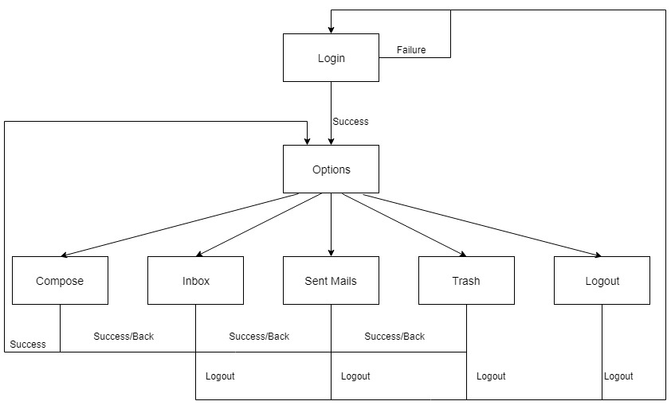
Fig 1. Block Diagram

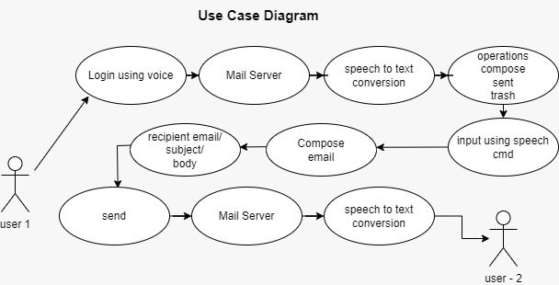
Fig-2 Use Case Diagram

In the above fig -2 it shows how user can compose an email easily using only voice command

4. CONCLUSIONS

The project that we have projected is a system which will help the visually impaired people to access email services efficiently. This system will help in overcoming some drawbacks that were earlier faced by the blind people in accessing emails. We have eliminated the concept of using keyboard shortcuts along with screen readers which will help reducing the cognitive load of remembering keyboard shortcuts. Also any non-sophisticated user who does not know the position of keys on the keyboard need not bother as keyboard usage is eliminated. Instructions given by the IVR accordingly to get the respective services offered. Other than this the user might need to feed in information through voice inputs when specified. This architecture will also reduce cognitive load taken by blind to remember and type characters using keyboard. It also helps handicapped and illiterate people.

5. REFERENCES

- The Radicati website. [Online]. Available: http://www.radicati.com/wp/wpcontent/uploads/2014/01/EmailStatistics-Report-2014-2018-Executive-Summary.pdf.
- G. Shoba, G. Anusha, V. Jeevitha, R. Shanmathi. “AN Interactive Email for Visually Impaired”. In International Journal of Advanced Research in Computer and Communication Engineering (IJARCCE), 2014 on Pages 5089-5092.
- Akif Khan, Shah Khusro, Badam Niazi, Jamil Ahmad,Iftikhar Alam and Inayat Khan, "Tetra Mail: A usable email client for blind people". Universal Access in theInformation Society-04 September 2018

- Prof. Umesh A. Patil, Pranouti B. Patil, Teja P. Magdum,Shweta K. Goud and Latika R. Bhosale, "A Survey on Voice Based Mail System for Physically Impaired Peoples". (IJIRCCE) - Volume 4, Issue 1, January 2016, pp. 1002-1006

